Project Development Phase
Model Performance Test

Date | 28 february 2026
Team ID
Project Name | Darshan ease
Maximum Marks

Model Performance Testing:
Project team shall fill the following information in model performance testing template.
S.No. | Parameter | Values | Screenshot
 | Model Summary | The Darshan Ease website is a digital platform designed to simplify temple visit planning. It allows users to check temple information, book darshan slots, view crowd status, and get guidance for smooth temple visits. | 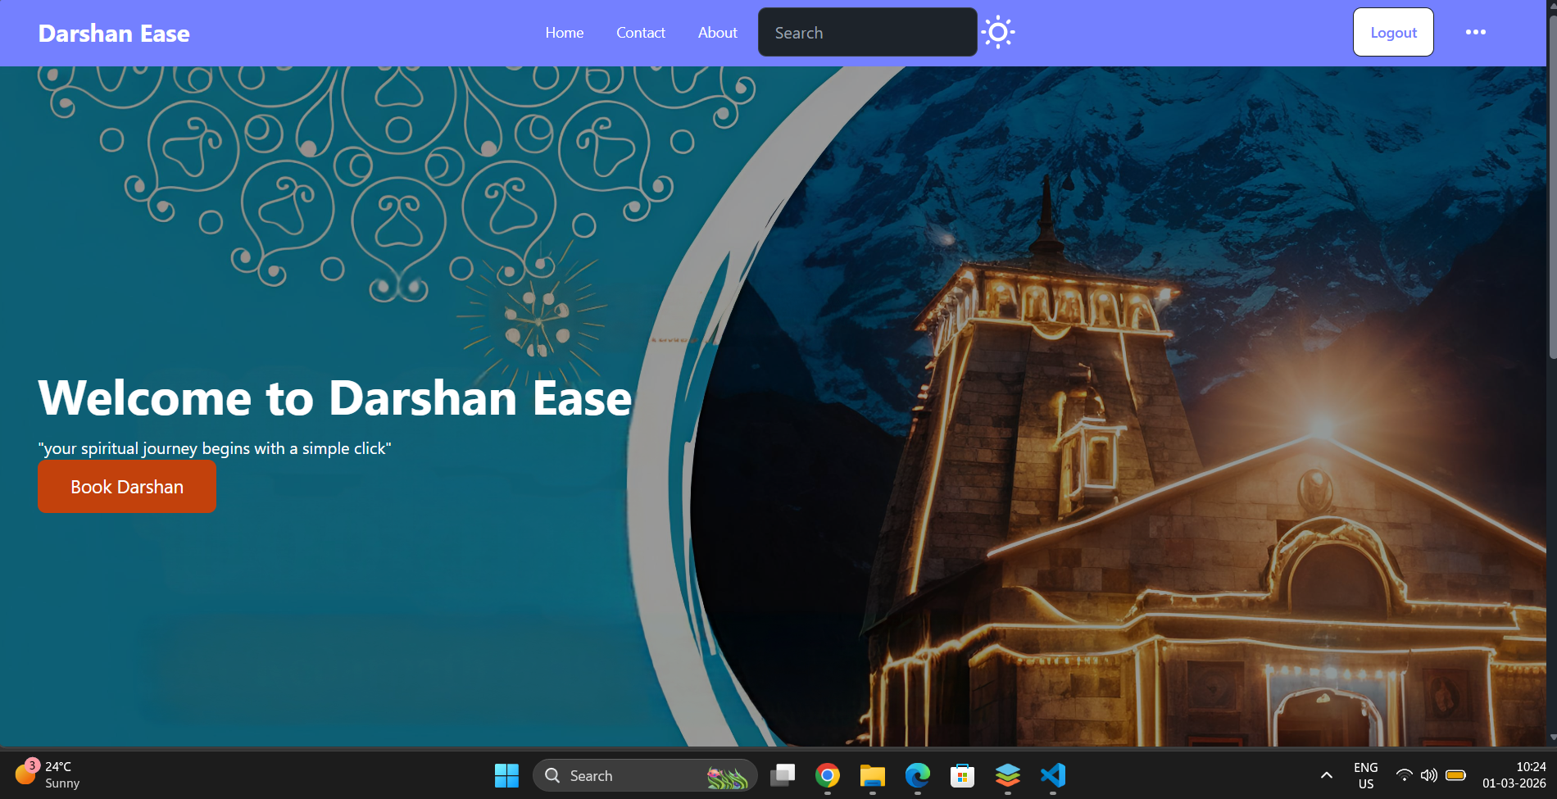
 | Accuracy | Training Accuracy: Not applicable for website model.  Validation Accuracy: System tested for correct page loading, booking process, and user interaction.  Booking page screenshot | 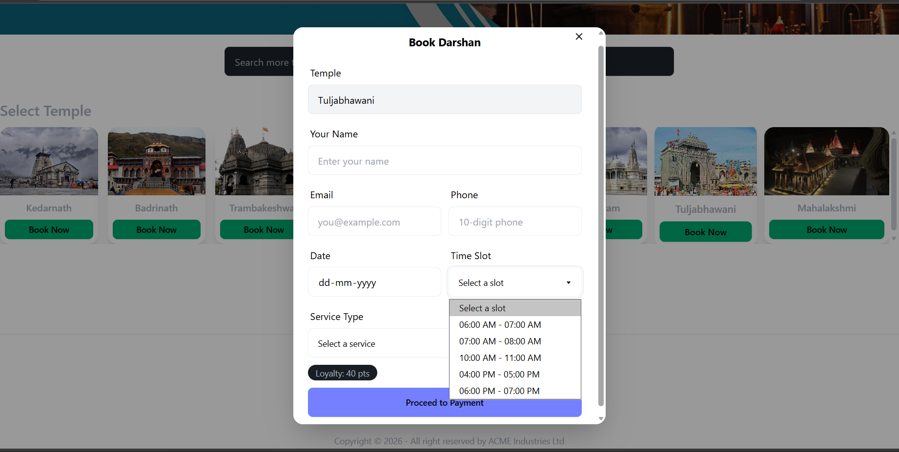
3. | Fine Tunning Result( if Done) | Website UI improved after testing. Navigation speed, form validation, and user interface were optimized for better performance.  Updated UI screenshot

